CO2
SIMULATION EXPERIMENT – 5
Electromagnetic Simulation and S-Parameter Characterization of a Microwave Directional Coupler and Two-Way Power Divider.

- Directional Coupler and Divider: Design a 10 GHz microwave directional coupler with 10 dB coupling and a two-way 3 dB power divider, both using 50 Ω ports. Simulate from 8–12 GHz. At 10 GHz obtain S11, S21, S31 and the isolated-port response. Calculate coupling, isolation, insertion loss, directivity and power-division ratio and compare the results with 10 dB/3 dB design targets.
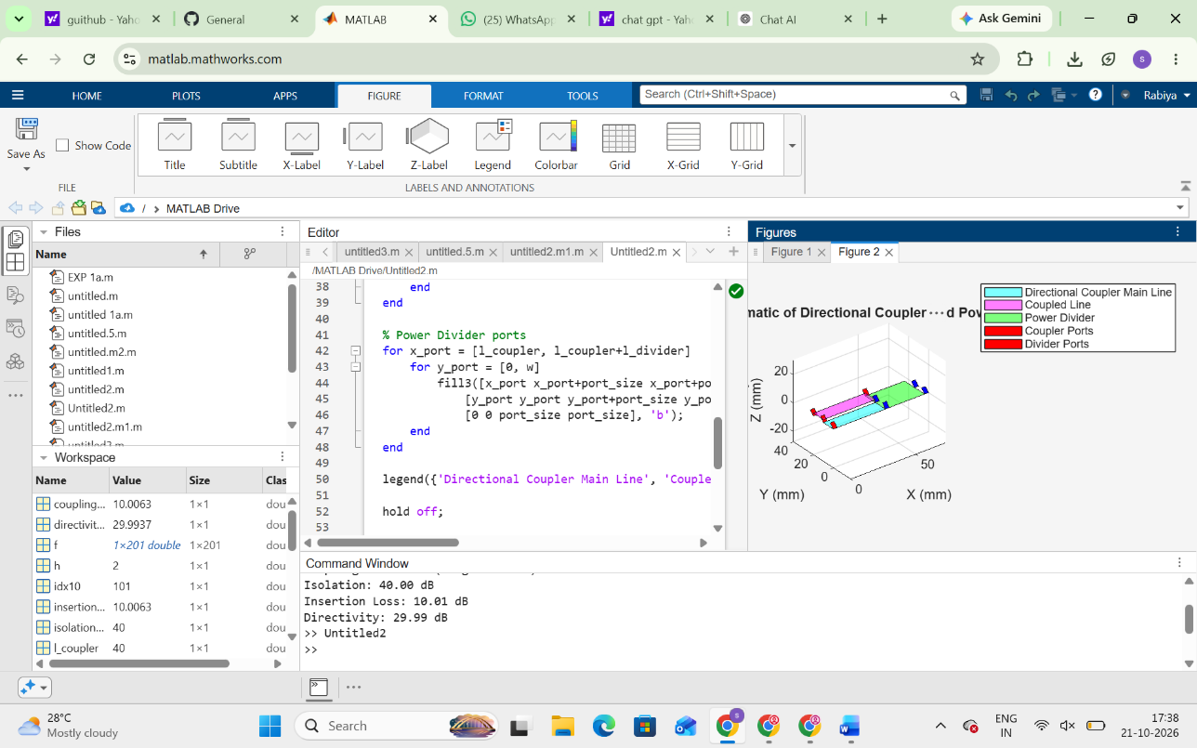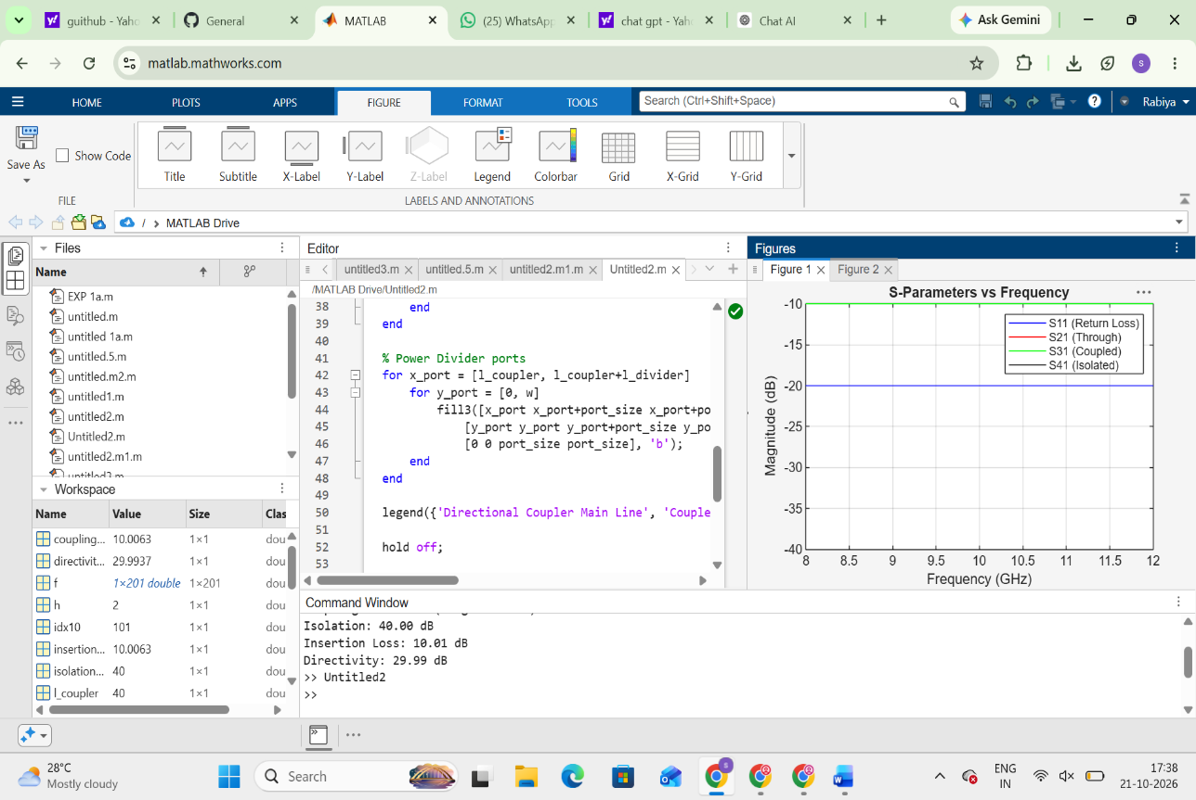

- Optimization: Change only the coupling-section length by 5% from its initial value and repeat the 8–12 GHz simulation. Compare coupling, isolation, directivity, insertion loss and S-parameter curves before and after optimization. Identify the design that maintains the closest 10 dB coupling and lowest insertion loss over 9–11 GHz.

